**Course Methods test 2 Year 12**

Student name: ________________ Teacher name: ________________

**Task type: Response**

**Time allowed for this task: ___40________ mins**

**Number of questions: ____8_______**

**Materials required:** Calculator with CAS capability (to be provided by the student)

Standard items: Pens (blue/black preferred), pencils (including coloured), sharpener, correction fluid/tape, eraser, ruler, highlighters

Special items: Drawing instruments, templates, notes on one unfolded sheet of   
A4 paper, and up to three calculators approved for use in the WACE examinations

**Marks available: ___41___ marks**

**Task weighting: _10___%**

**Formula sheet provided: Yes**

**Note: All part questions worth more than 2 marks require working to obtain full marks.**

Q1 ( 3 & 3 = 6 marks) (3.2.9)

Determine  in terms of  for the following. Show all working.

1.  and  when .
2.  and  when .

Q2 (3 & 2 = 5 marks) (3.2.22, 3.2.5)

A car travels in a straight line from the origin, initially at rest, with constant acceleration with  time in seconds.

1. Determine the distance from the origin at  seconds?
2. What is the velocity of the car at  seconds?

Q3 (2 marks) (3.2.19)

Determine the exact area between  and the  axis from  to .

Q4 (2, 2 & 3 = 7 marks) (3.2.18)

A factory produces electric vehicles. The total number, , that the company has produced  months after production commenced is such that:



Determine the number produced in

1. The first 6 months
2. The third month

Determine the minimum number of months required to produce:

1. 10000 vehicles.

Q5 (5 & 3 = 8 marks) (3.2.20)

1. On the axes below, sketch the following graphs:  and . Indicate on your sketch coordinates(one decimal place) of any stationary points, and label their nature, and of any points where the graphs intersect each other.

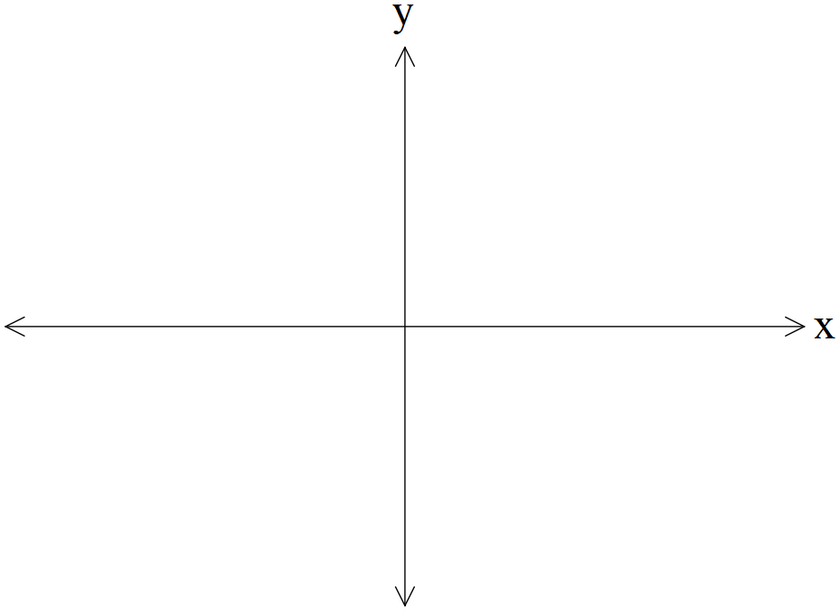

1. Determine the exact area between  and .

Q6 (2 & 2 = 4 marks) (3.1.3, 3.1.4)

The number of kangaroos,  in a particular site that have developed disease W are increasing such that  with  the time in years. There are initially 2300 kangaroos with the disease.

1. Determine the number of kangaroos with disease W in 5 years’ time.
2. Determine the time taken to triple the number with the disease in years to one decimal place.

Q7 (4 marks) (3.2.16)

Consider the function  such that  and .

Determine the rule for the function .

Q8 (5 marks) (3.1.15)

Consider the function  where  are constants.

Below is a graph of  (Note: diagram is not drawn to scale)

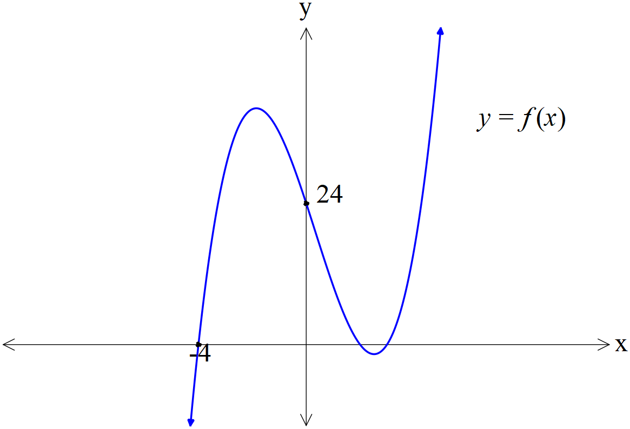

There is an  intercept at ,  intercept at  and .

There is an inflection point at .

Determine the exact values of .